Python and Mongodb

**Assignment 04**

COHDCBIS182F – 006

R.N. Abeysinghe.

Setting the Path

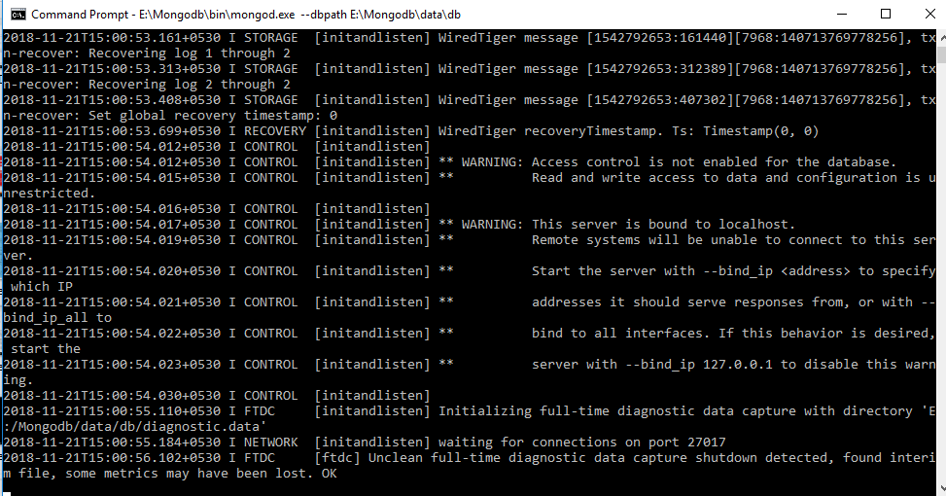

Installing pymongo

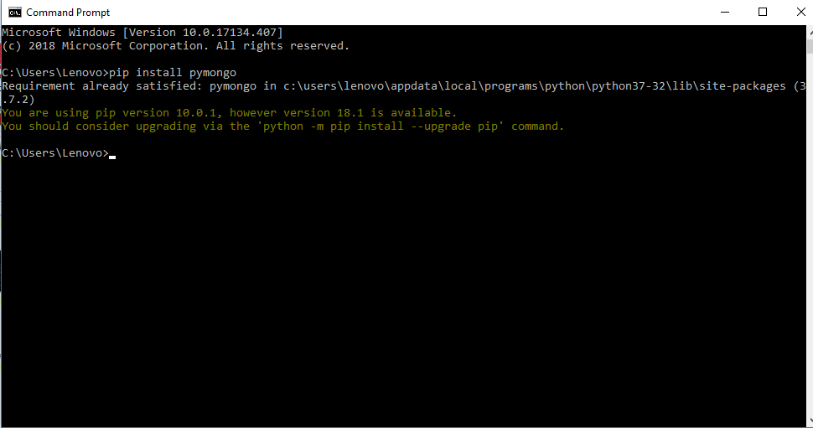

Running the mongo.exe file in cmd

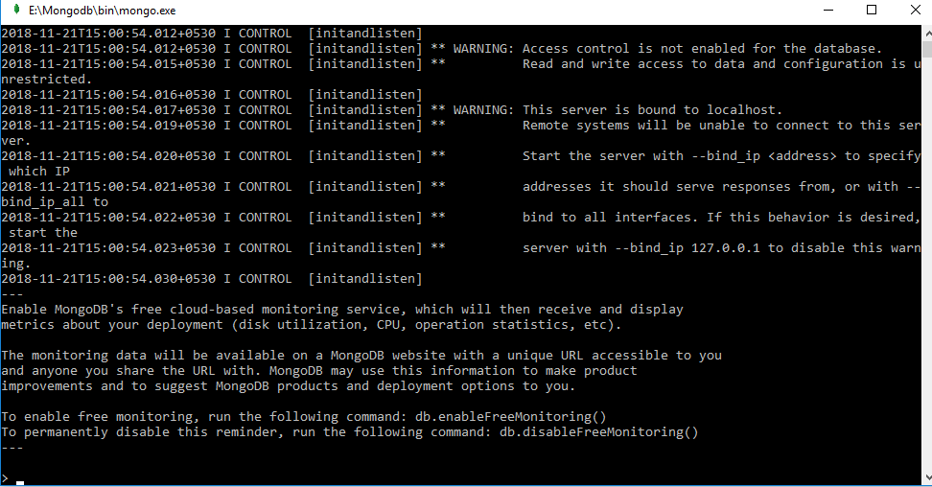

Creating the database, collection and insertion of data

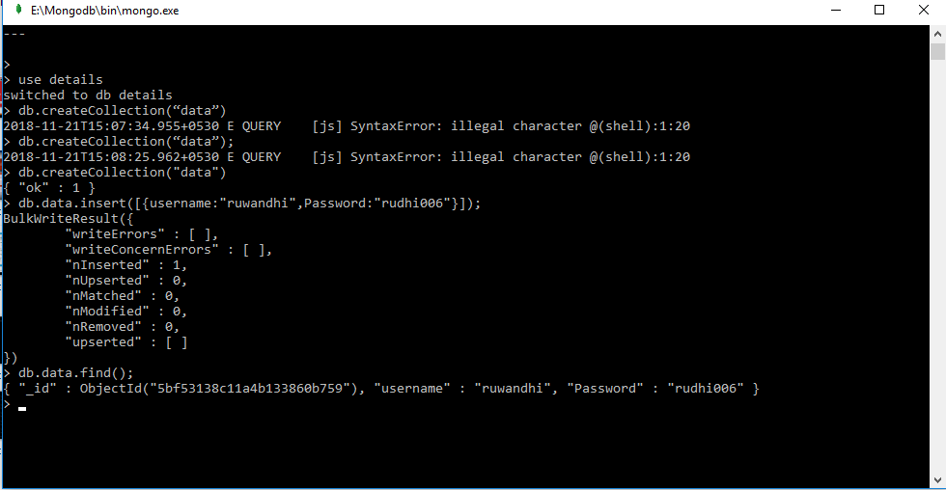

Customer login form code

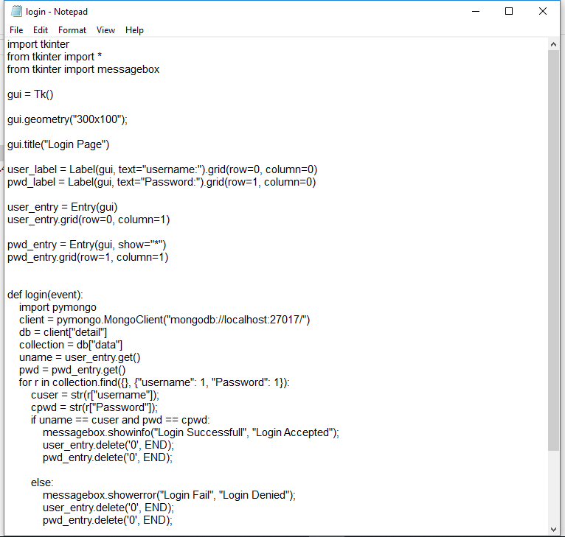

Executing and entering accurate data

